**SQL question:**

We are given 2 tables: product and sales:

Products

|  |  |
| --- | --- |
| prodcut_id |  |
| brand_name |  |
| class_id |  |
| price |  |

SALES

|  |  |
| --- | --- |
| product_id |  |
| sales_id |  |
| promotion_id |  |
| sales_price |  |

# find all brand names with average price at lease 3 and producing at least 3 items

# find the perchance of no-promotion sales to total number of promotions

# find the top 3 class of products which has the highest total sale price.

**Programing Questions**

1. write a function to take a string of words and find the average length of words.

1. write a function to check the balance of parenthesis
2. take a list of lists which represents the friendship relation and return a dictionary which represents the number of friends for each person

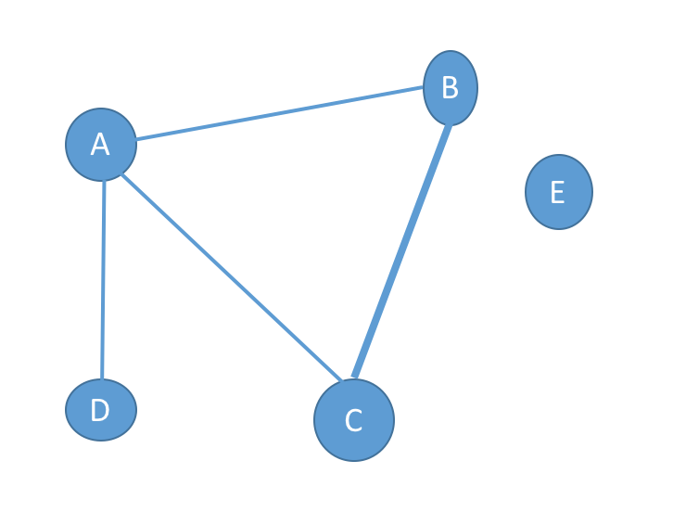

Example: Input: [[A,B], [A,C],[A,D],[B,C], [E]]

Output: {A:3, B:2, C:2,D:1, E:0}

1. ### take a string and check if it is valid ip address or not:

Avalid has the form 123.234.567.213 and all the numbers should be less than 256 and larger than zerp